***East Baton Rouge, Louisiana* Dataset**

Baseline data pre-processing methodology

1. Filtered by cases that indicate to be in ‘Released’ status (those that have both booking and release date; if not released, then the status is equal to the booking date) and have at lease 0 day(s) of stay in jail (release minus booking date), or in other words, all ongoing cases are removed, so that we can observe and relate bail bonds times of stay in jail

Statistics/Graphs

1. Average bail bond amounts for each (RACE) and (RACE, SEX) distribution, computed in Table 1a and 1b and frequencies plotted in Graph 1a and 1b.

**Table 1a.**

|  |  |  |
| --- | --- | --- |
| **Race** | **Sex** | **Average Bail Bond Amount ($)** |
| Asian | F | 6,428.57 |
|  | M | 5,740.74 |
| Black | F | 4,843.88 |
|  | M | 14,628.34 |
| Hispanic | F | 625.00 |
|  | M | 16,372.77 |
| None | F | 200.00 |
|  | M | 12,852.72 |
| White | F | 6,671.53 |
|  | M | 6,412.34 |

**Table 1b.**

|  |  |
| --- | --- |
| **Race** | **Average Bail Bond Amount ($)** |
| Asian | 5,975.60 |
| Black | 13,480.03 |
| Hispanic | 15,573.73 |
| None | 12,744.88 |
| White | 6,470.87 |

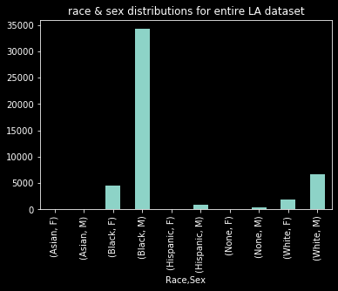**Graph 1a. Counts by Race & Sex**

**Graph 1b. Counts by Race**

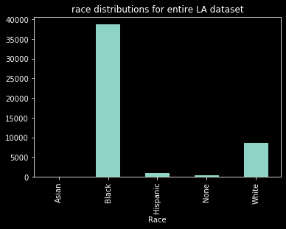

1. Only cases with bail bond amounts under $5,000 are considered as The Bail Project only assists those with bonds < $5,000. The bin taken for this case is (0, 5000] (that is, 0 exclusive, 5,000 inclusive). Average time spent in jail and average bail bond amounts are computed in Table 2a and 2b, and the frequencies are plotted in Graph 2a and 2b.

>> * observe carefully with the number of people that fall into the category (‘Count’)

**Table 2a.**

|  |  |  |  |  |
| --- | --- | --- | --- | --- |
| **Race** | **Sex** | **Time in Jail (Days)** | **Average Bail Bond Amount ($)** | **Count** |
| Asian | F | N/A | N/A | N/A |
|  | M | 0 | 5,000 | 1 |
| Black | F | 49.73 | 1888.68 | 576 |
|  | M | 58.16 | 1863.21 | 2188 |
| Hispanic | F | N/A | N/A | N/A |
|  | M | 74.00 | 3559.00 | 50 |
| None | F | 5.33 | 200.00 | 3 |
|  | M | 76.22 | 3711.11 | 36 |
| White | F | 55.43 | 2380.07 | 269 |
|  | M | 80.11 | 2300.06 | 535 |

**Table 2b.**

|  |  |  |  |
| --- | --- | --- | --- |
| **Race** | **Time in Jail (Days)** | **Average Bail Bond Amount ($)** | **Count** |
| Asian | 0 | 5,000.00 | 1 |
| Black | 56 | 1,868.52 | 2,764 |
| Hispanic | 74 | 3,559.00 | 50 |
| None | 70 | 3,441.02 | 39 |
| White | 71 | 2,326.83 | 804 |

**Graph 2a.**

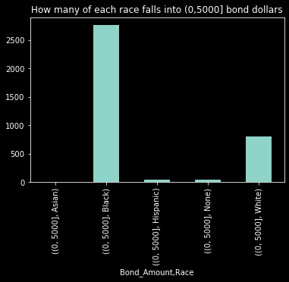

**Graph 2b.**

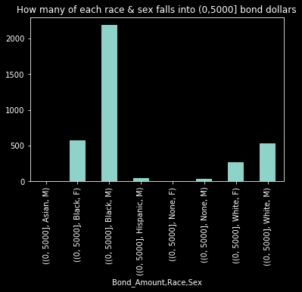

1. Trend analysis: how many people stay for how long in jail? (*note: there are a couple extreme outliers that cause the bounds of the graph far outward, so this graph is limited such that it can closely zoom in to the majority; also A LOT for $0 due to systematic tradition; anything greater than a full year (365 days) is put into a ‘365’ which is why we see a jump at ‘365 days’)

>> concentrated at lower (around < 200 days)

>> refer to **durations.csv**

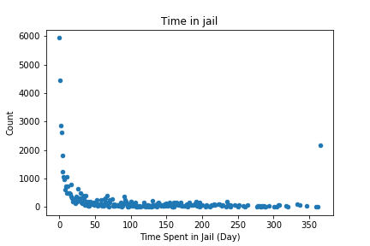

Trend analysis: how many people pay for how much bail bonds?

** only those with < $5,000 bonds are of interest here because The Bail Project focuses on those with <$5,000

>> pretty consistent number of people throughout bail bond amounts **refer to **bondamts.csv**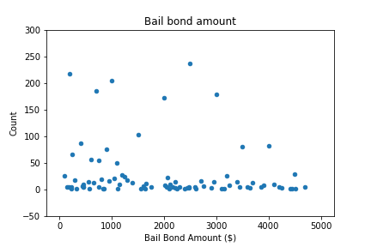

1. General statistics for ***< East Baton Rouge, Louisiana >*** overall
   1. All races: {'Asian': 41, 'Black': 38761, 'Hispanic': 946, 'None': 352, 'White': 8551}
      1. {'Asian': '0.12', 'Black': '77.84', 'Hispanic': '2.47', 'None': '0.84', 'White': '18.72'}
   2. All sexes: {'F': 6545, 'M': 42106}
   3. All charges: 297 different categories (incl. sub categories)
      1. Refer to **charges.json**
   4. Average bail bond amount per race

{('Asian', 'F'): 30000.0,

('Asian', 'M'): 37068.181818181816,   
('Black', 'F'): 31497.55859676176,   
('Black', 'M'): 73299.45880183387,   
('Hispanic', 'F'): 10108.695652173914,   
('Hispanic', 'M'): 88959.41441441441,   
('None', 'F'): 200.0,   
('None', 'M'): 57026.64756446992,   
('None', 'None'): 0,   
('White', 'F'): 34711.952969310485,   
('White', 'M'): 33976.1312655774}

* 1. Average sex percentage per race
     1. {('Asian', 'F'): '45.00',   
        ('Asian', 'M'): '55.00',   
        ('Black', 'F'): '11.33',   
        ('Black', 'M'): '88.67',   
        ('Hispanic', 'F'): '1.43',   
        ('Hispanic', 'M'): '98.57',   
        ('None', 'F'): '4.01',   
        ('None', 'M'): '82.33',   
        ('None', 'None'): '13.66',   
        ('White', 'F'): '24.50',   
        ('White', 'M'): '75.50'}

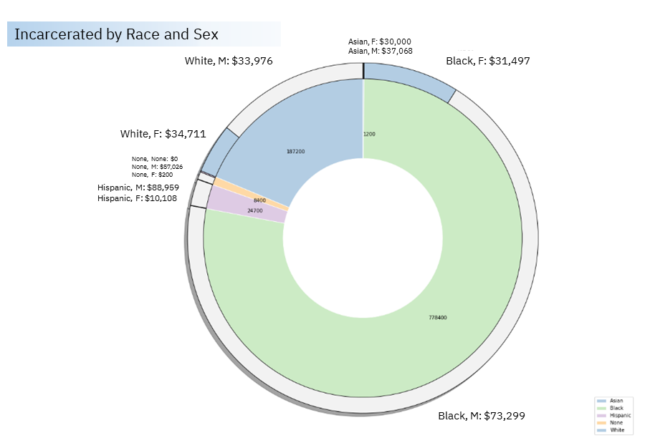

1. Drug schedules and demographic relations with counts and averages
   1. Refer to **df_sex_race_status_count.csv**